Faculty of Computing

CS-212: Object Oriented Programming Class: BSSE-16A

Assignment-1: Graphics (Fractals)

Date: 17 Feb 2024

Instructor: Dr. Aimal Rextin

Assignment – 1: Graphics (Fractals)

Description:

In class, we studied some very basic graphics of Java. More functions in the Graphics class such as drawing rectangles and ovals etc. You can read section 5.11 of your textbook for more details.
In today’s assignment, we will study a special type of graphics called fractals. A fractal is a complex geometric shape consisting of parts which are a reduced-scale copy of the whole. Fractals are usually self-similar, i.e. they look similar at any scale, whether you zoom in or out. They are generated by repeating a simple process repeatedly recursively.

One of the simplest fractals is called a Sierpinski Triangle, which is constructed by recursively dividing an equilateral triangle again and again. The basic steps are as follows:
- Start with an equilateral triangle, color it.
- Subdivide: find the midpoint of each side of the triangle. These are the corners of a smaller equilateral triangle in the center. Color this central triangle white. This creates 4 smaller triangles. One central white triangle and 3 black equilateral triangles.
- Repeat step 2 with each of the remaining smaller triangles until a base case is reached.
The below figure shows the initial few steps of how it works:
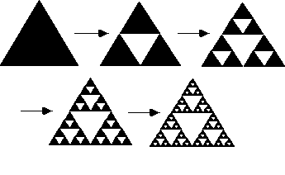

Tools/Software Requirement:
Java

Assignment Task:
Minimum Code Requirement
- You would have a class Sierpinski with the following.
- Constructor that allows the user to define the length of a single side in the top-level triangle.
- Function run: this will initiate the drawing process recursively.
- Setter and getter for base case: this will allow you to set the length of a side when you will terminate the recursion, such as say 2 pixels or 5 pixels
  - You may also have a default base case
- One or more private functions to make the code modular without complicating life for the programmer working in the main function.
- Any extra feature would increase marks.

Deliverables and other information:

  - Assignment Report and complete source code (programming files) in Zip Format.
  - Deadline of submission is Sunday 25 Feb 11:59 PM

